
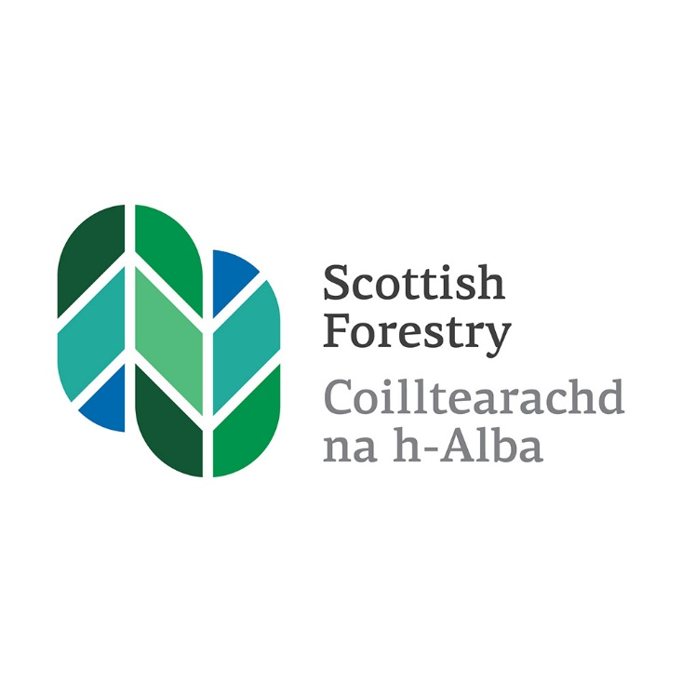

Strategic Timber Transport Scheme: Planning ahead for your application (2025-26)

Scottish Forestry is the Scottish Government agency responsible
for forestry policy, support and regulation
Is e Coilltearachd na h-Alba a’ bhuidheann-ghnìomha aig Riaghaltas
na h-Alba a tha an urra ri poileasaidh, taic agus riaghladh do choilltearachd

Where to start?
When considering an application to the Strategic Timber Transport Scheme (STTS) it is important that both the Regional Timber Transport Group (RTTG) and the potential STTS applicant builds time into their project planning to ensure that the Forestry (Environmental Impact Assessment) (Scotland) Regulations 2017 (EIA regs), planning and UKFS requirements are all met in advance.
To do this, applicants will need to consider the following:
Do you need UK Forestry Standard (UKFS) compliant Forest Plans?
When an STTS application is submitted the relevant Conservancy Offices are consulted on the bid. Where public funds are being used to support transport projects there should be an appropriate level of planning behind the bid.
Without appropriate planning, the Conservancy may still agree that the project could be strategically important but may not have enough information to decide whether a project is likely to have a significant impact on the environment, or that associated felling plans will meet the UKFS.
These are all points that might lead to future delays in realising the timber volume to support the project. We recognise development of collaborative projects is often an iterative process, however, to give it full support the Conservancy will:
- look for planning to have been considered beyond a Production Forecast (ideally through completion of an approved Forest Plan, but if not then concept / felling and restock maps should be submitted so that UKFS and major issues can be raised), and;
- expect the screening process to have been completed and that an EIA reg. screening opinion has been issued.
Does your project need planning permission, prior notification, or screening through the EIA regs?
It is always best to liaise with your SF Conservancy Office to determine what permissions are required for your project at an early stage. Approvals can take some time to complete and can sometimes identify previously unknown issues. Depending on the situation and proposed use of the road, a combination of prior notification and a Forestry (Environmental Impact Assessment) (Scotland) Regulations 2017 screening opinion are likely to be required.
Prior Notification through the Local Planning Authority (LPA) is now required for the formation and alteration of private ways (which includes forest roads). Approaches and interpretation differ between various LPAs, as a result of some differences in interpretation of the Town and Country Planning (General Permitted Development) (Scotland) Amendment (no 189) Order 2017.
In some circumstances, planning permissions from the Local Planning Authority will also be required e.g.:

- When a forest road joins the public highway (the first 25 metres + the access onto the highway), and;
- when forest roads are in National Scenic Areas (except those used for ‘afforestation’).
The end or main use of ‘mixed use’ roads will need to be taken into consideration when deciding on the Competent Authority for the consenting process, whether that is via planning permission or Forestry EIA regs. National Parks in Scotland will have developed an agreed protocol with the local SF Conservancy office.
Environmental Impact Assessments (EIA)
Scottish Forestry (SF) is responsible for administering the Forestry (Environmental Impact Assessment) (Scotland) Regulations 2017. Guidance on the regulations and application for consent forms is available on-line. Some types of forestry project are likely to have a significant impact on the environment. If the area covered by your project is over the threshold for that type of project, then you must apply for a formal opinion to see if our consent is required before you can begin work.

How long might it take?
The regulations require that we make our decision within 28-days of receiving all the relevant information, but we might ask you to agree to a longer period. We can only make a decision when we have all the relevant information, and we may ask you for more information in addition to that you have already given us. This will restart the 28 days.
- If consent is NOT required - then you can start work, or we will continue to process your application for grant aid / felling permission in the normal way.
- If consent IS required - you must apply for consent if you wish to proceed with the work. Your application must include an EIA Report.
So, to prevent unexpected delays during the STTS application period it is important that this work is completed in advance and is well considered including:
- Specification, construction details and standard.
- Footprint and tolerances.
- Stream crossings - culverts / bridges/comments on need for CAR licenses etc.
- Environmental constraints.
- Borrow pits / quarries.
- Other relevant projects – e.g. connecting roads built within 5-years.
Special Challenges for Collaborative Applications?
Planning
Other issues can conspire to delay submission for an EIA screening opinion. Negotiations across joint ownerships in particular may not resolve until late in the project, or there may be issues of commercial sensitivity.
Collaborative Applications
Should be treated as one project through the EIA regs, regardless of ownership. They may however need separate felling permission applications for various owners. Getting all this information from applicants at the same time means SF can assess it more efficiently and undertake one process. Screening can potentially be carried out on more than one alternative or with a tolerance - but the options presented still need to be reasonably robust.
Roads - Is your specification fit for purpose?
- In many collaborative projects there will be a variation in the use of sections of road depending on which direction the majority of timber is leaving e.g. if it is a dead-end road the specification at one end may well need to be higher than at the other.
- There may be joint use that puts the road under increased pressure from different types of vehicles.
- Haul routes will need to carry more lorries than a standard forest road and may well be subjected to peaks in activity from more than one owner.
- Full consideration should be given as to how a collaborative road will be used to make sure the specification is fit for that purpose before any STTS application.
Construction and maintenance
In many collaborative projects there will be a variety of different levels of experience of road building among agents and owners. If individual owners are undertaking work themselves, either construction or maintenance, as part of the project then there needs to be a clear agreement about specification and timing.
Management regimes, partnership agreements, servitude rights and leases can all have a ‘make or break’ influence on the success of project in the long term.
Think ahead – what might go wrong and try to ‘future proof’ your project. Agreements should include procedures to safeguard the road during forest operations, especially in winter periods subject to severe wet or frosty weather.
Last minute curve balls, such as environmental constraints, may cause further delays in the construction timetable or maintenance regime.

In summary:
- There are planning issues specific to collaborative projects.
- An EIA screening opinion should be sought at an early stage when considering making a bid for STTS.
- Build enough time into your project to secure appropriate prior notifications, planning permissions, EIA opinions and UKFS requirements.
- EIA Screening opinion requests and Felling Permissions should be done collaboratively and in sufficient detail.
- Forest Plans or agreed maps (of sufficient quality!) should be submitted to SF.
- Standards for road construction, management and maintenance should be clear, detailed and agreed in advance, and included with any application.
If you require clarifications or advice please contact: stts@forestry.gov.scot
Scottish Forestry is the Scottish Government agency responsible
for forestry policy, support and regulation
Is e Coilltearachd na h-Alba a’ bhuidheann-ghnìomha aig Riaghaltas
na h-Alba a tha an urra ri poileasaidh, taic agus riaghladh do choilltearachd

